‘Eye in the Sky’: Legal Argument Scene
(in real time so all edits are cuts)

Frame | Audio | Technical Description
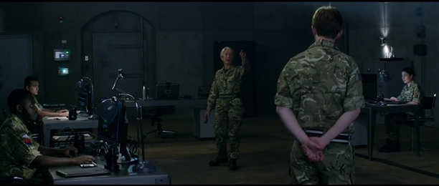1 | Powell: So the plan is to put a Hellfire through the roof of that house. | LS Bunker  Establishing shot  180˚ line between Powell and Harold  Shot …  Eyeline match to …
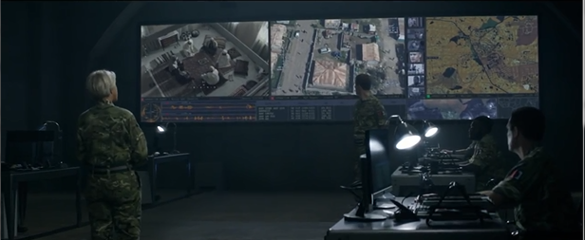2 | P: I need legal clearance right now.  Harold: A missile from the Reaper?  P: Yes.  H: So this is no longer a capture situation?  P: No. | … reverse shot  LS Screen in Bunker  Camera tracks round to right
3 | P: We have 2 suicide vests with explosives inside that house. | Shot …  OS LS Powell
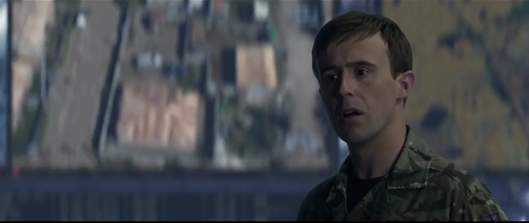4a | P: So can you clear me to a higher CDE?  Harold: (under his breath) Ah! | … reverse shot  MCU Harold
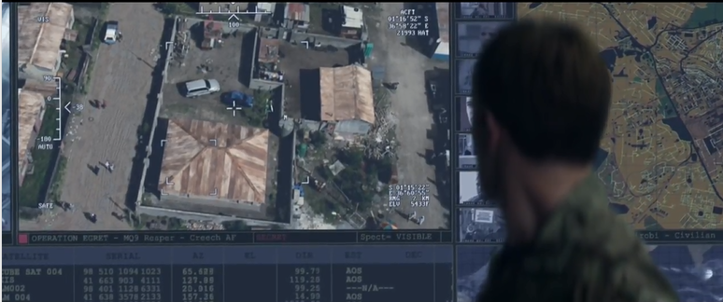4b |  | Rack focus from Harold to screen
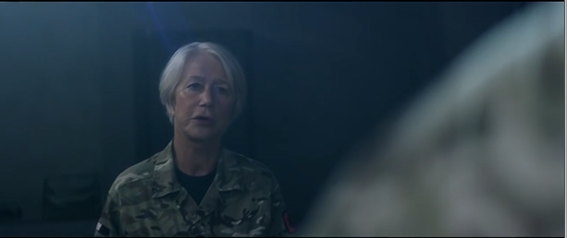5 | P: (walks forward) Harold, this is a very time-sensitive target. Do I have authority … | Shot …  OS MCU Powell
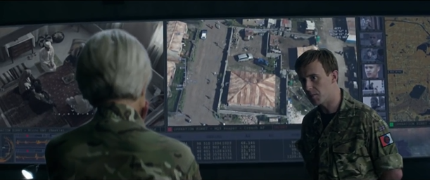6 | P: (stops)… to strike?  H: The rules of engagement you’re operating under only allow for a low collateral damage estimate.  P. Yes yes. | … reverse shot  OS MS Harold
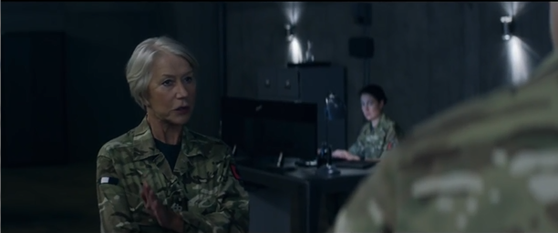7 | P: And my weapons only invoke a low CDE. | Shot …  OS MS Powell
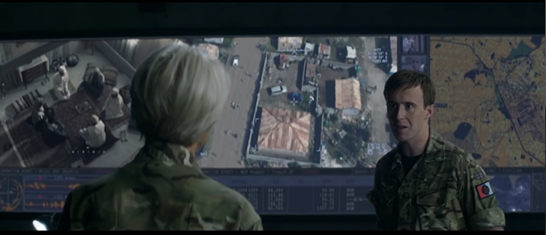8 | P: It’s the explosives in that house that bring it to a potentially high CDE.  H: And since you know the explosives are there, it is incumbent upon … | … reverse shot  OS MS Harold
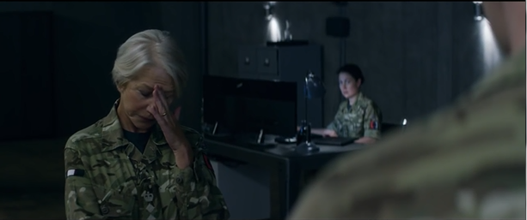9 | H: … you to take them into account. I can see a potential legal objection.  P: Jesus! We’ve got 2 suicide bombers and 3 very high value individuals inside that house.  H: And you want them off your list. I understand that. | Shot …  OS MS Powell
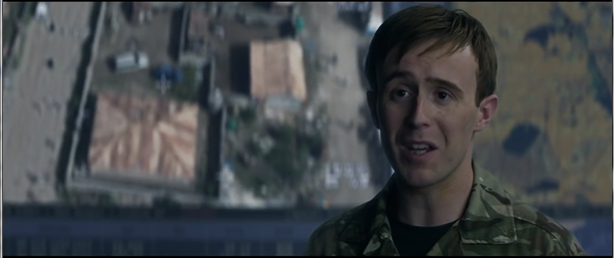10 | H: But the rules of engagement you’re operating under envisaged a capture … | …reverse shot  MCU Harold
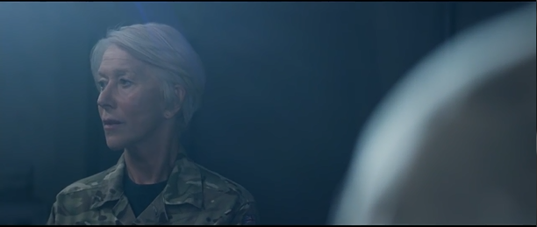11 | H: … not a kill scenario. (pause then steps tentatively towards Powell) Ma’am, I .. I think it would wise … | Shot …  OS MCU Powell  Match on action to 12
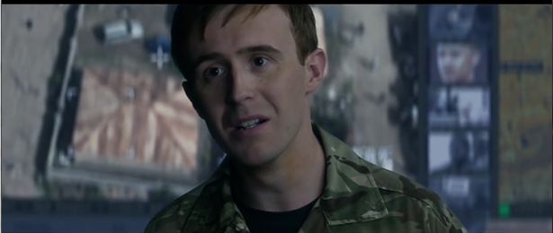12 | H: (stops) … to refer up. | … reverse shot  CU Harold
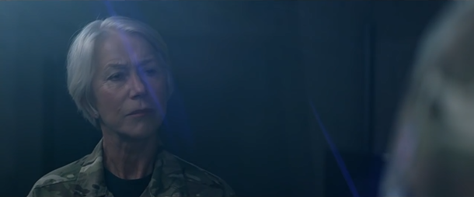13 | Powell walks up to Harold | Shot …  OS MCU Powell  Match on action to 14
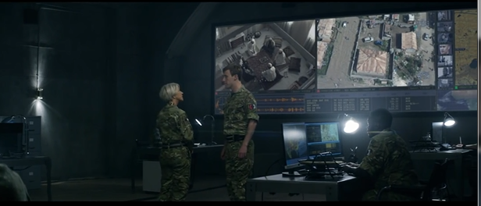14 | P: (still walking) Are you telling me that or are you just debating with me?  Harold stands his ground | Re-establishment shot  MLS Powell and Harold
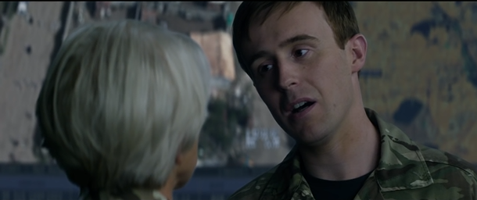15 | H: To refer up?  P: Mm.  H: I am telling you. | Shot …  OS CU Harold
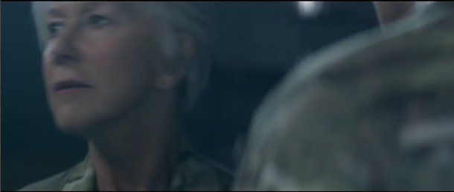16 | P: (exasperated) Ohhh!  Powell walks away | … reverse shot  OS CU Powell

